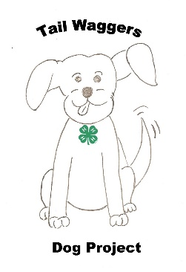
TailWaggers
Invitational Dog Show
Hosted by TailWaggers 4-H Dog Project
Johnson County, KS

Saturday; June 27, 2026
Johnson County Fairgrounds
136 E Washington St; Gardner, KS 66030

Showmanship, Obedience, Rally Obedience, and Agility
~This show is a State Qualifier Dog Show for the Kansas State Fair 4-H Dog Show!~

Pre-Registration due: June 20, 2026; Walk In Entries will be welcome!

Pre-registration fees are $10 per event
Walk-in fees are $15 per event

Enter online: https://forms.gle/dL7PZAjdhreimM226
or mail in the attached entry form

Check In begins at 8:00 AM; Walk-Ins Close at 8:30 AM.
Show will start at 9:00 AM.

Come join us for a day of fun with our dogs!
We welcome all 4-Hers enrolled in the 4-H Dog Project.

This show will be governed by the Kansas 4-H Dog Show Rule Book.
A "4-H Dog Show Immunization Record" must be provided with all entries.

Help us keep our facility clean and available for future use. Please clean up after your dog and remove all trash. THANK YOU for your cooperation!

For additional information call
Donna Holloway 913-433-6752; donnaLholloway@yahoo.com
Audrey Small 913-963-6617; Ajsmall439@gmail.com

The Tail Waggers 4-H Dog Project Group, Johnson County Extension Office, and the Johnson County Fair Board will not be responsible for any loss, theft, injury, or death of dogs attending this show nor are they liable for any injury to those participating for attending this show.
TailWaggers 4-H Invitational Dog Show Registration Form – June 27, 2026

Name_______________________________________ County_____________ 4H Club______________________
4-H Age_____ (before January 1, 2026); Email: ________________________________________ Phone ____________

Event | Level | Dog’s name | Breed | Height  (inches) | Fee**
Showmanship | Pre Junior (7-8)
 | Junior (9-11)
 | Intermediate (12-14)
 | Senior (15+)
Obedience | Pre Novice A (SubA)
 | Pre Novice B (SubB)
 | Novice
 | Grad-Novice
 | Open A *
 | Open B *
 | Utility A *
 | Utility B*
Rally | 1
 | 2
 | 3
Agility | 1 - On Lead
 | 1 - Off Lead
 | 2
 | 3
 | 4
TOTAL FEE
* Equipment not provided; you must bring your own. Please complete additional forms if you have more than one dog in the same event and level.

** Pre-registration fees are $10 per event; Walk-in entry fees are $15 per event**

Please Make Checks Payable to: TailWaggers 4-H Dog Project
Mail entry form, payment, and a copy of immunization record to:
Donna Holloway
6400 W 183rd St
Stilwell, KS 66085

