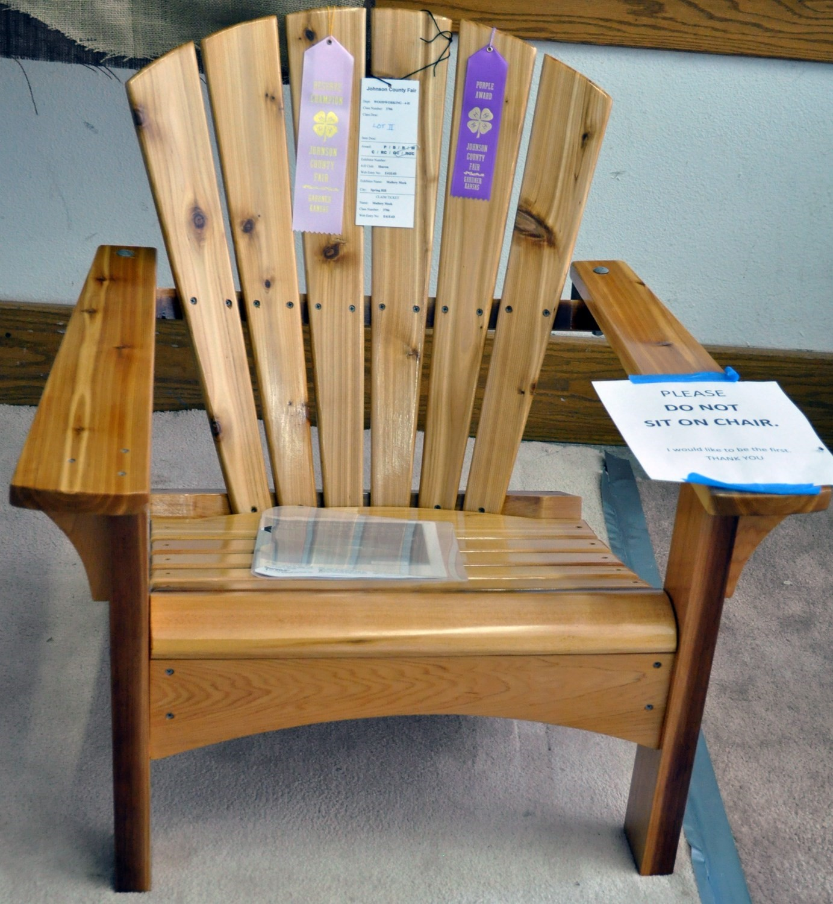
2022 Johnson County Fair
4-H Project
Auction
Friday, August 5
8 pm, Livestock Pavilion
Come invest in the Johnson County 4-H youth as they offer their projects for sale! Your support helps them recoup project expenses and fund future projects, education, etc.
It’s Simple!
- Look for items tagged “Buy Me at Auction” in the Green 4-H Building.
- Register as a Buyer at the South End of the Livestock Pavilion beginning at 6:30 p.m. on Friday.
- Bid on your favorite item(s)!
- Check out with cash, check, or credit card (fees apply) at the Grange Building.
Thank you for supporting our youth!
The Johnson County Fair is August 1 – 6, 2022 at
136 E. Washington St., Gardner, KS

