The type food safety of frostings and fillings should be considered as you plan your food entries for the Johnson County Fair. It can be a little confusing to know what frostings and fillings are safe to use in your fair foods so here is a brief summary and some recommendations.
Frostings and fillings that have a minimum of 65% sugar by weight is necessary to ensure the frosting is safe and stable at room temperature. It is important to know that not all receipes are the same and variations to recipes can change the water activity and food safety risk.
To determine the percent sugar in your recipe, measure each ingredient in grams to find the total weight. [Note: Corn syrup is only 70% sugar and the rest is water].Then divide weight of sugar by the total weight of the receipe and multiple by 100 to find your percent sugar.
% sugar = (sugar weight ÷ total weight of recipe) x 100

Note that the weight is measured in grams. A metric kitchen scale is helpful to measure weight or you may also use any website that provides weight equivalents for household measurements. Here is an example of a safe frosting recipe.

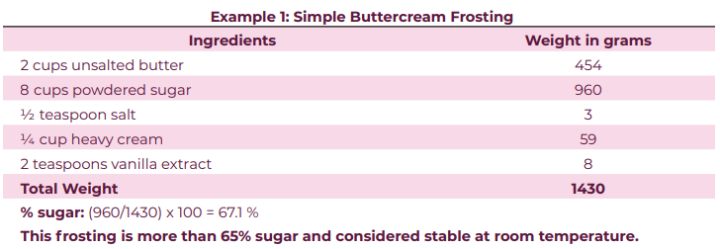
Remember that for Kansas fairs and exhibitions, the following ingredients or foods are NOT allowed:
- Raw eggs in uncooked frostings or fillings
- Raw flour in uncooked frostings or fillings
- Cream cheese frosting or filling
- Chocolate ganache
- Heavy cream frosting
- Lemon curd
- Fresh cut/whole fruit or vegetables as garnishes
- Custard pie
- Cream pie
- Chiffon pie
- Fresh (unbaked) fruit pie (ex: fresh strawberry pie)
- Any meat
- Friendship bread starter, not refrigerated
Please contact the Extension Office (913) 715-7000 with any questions.
Source: https://bookstore.ksre.ksu.edu/pubs/MF3544.pdf

